DSC650 Big Data Final Project
Tejashri Bhilare
MS in Data Science, Bellevue University
DSC650 – Big Data
Professor - Nasheb Ismaily
February, 2025

AI/ML Salaries

1. Introduction
Objective
The goal of this project is to build a data pipeline that integrates four major components from the Big Data ecosystem: NiFi, HDFS, Hive, HBase, and Spark.
The pipeline will demonstrate the movement and transformation of data across these components, ensuring seamless integration, efficient querying, and processing of large-scale data.

Technologies Used
Apache NiFi – Data ingestion from a remote source (GitHub)
HDFS (Hadoop Distributed File System) – Storage of raw data
Apache Hive – Structured querying and data warehousing
Apache Spark – Data processing and analytics

2. Dataset

Dataset Name: AI Salaries
Source: https://www.kaggle.com/datasets/cedricaubin/ai-ml-salaries
- Description: This dataset provides salary details for AI professionals, including work experience, job titles, salary figures (in different currencies and USD), company location, and employment type.
- Columns in the dataset:
  - work_year – Year of employment
  - experience_level – Junior/Mid/Senior level
  - employment_type – Full-time, Contract, etc.
  - job_title – Role of the employee
  - salary – Salary in local currency
  - salary_currency – Currency of salary
  - salary_in_usd – Salary converted to USD
  - employee_residence – Location of the employee
  - remote_ratio – Percentage of remote work
  - company_location – Location of the company
  - company_size – Company size (S, M, L)

• Number of Records: Approximately 3,750 rows , however have fetched only 50 rows from it.
• File Type: CSV (Comma-Separated Values).

3. Data Pipeline Overview

Pipeline Steps & Components

- Data Ingestion with Apache NiFi
- Fetch data from GitHub using GetHTTP processor.
- Store in HDFS using PutHDFS processor.
- Storage in HDFS
- Data stored in /data/AI_Salaries.csv for further processing.
3️) Hive Table Creation & Data Loading
- Data structured and stored in Hive Table for querying.
4) Processing & Analysis in Spark
- Run transformations and analytics using Spark SQL.

4. Implementation & Code

Step 1: Ingest Data into HDFS (Apache NiFi)

Copy dataset into own GitHub directory
https://github.com/Tejashri-Bhilare/DSC650

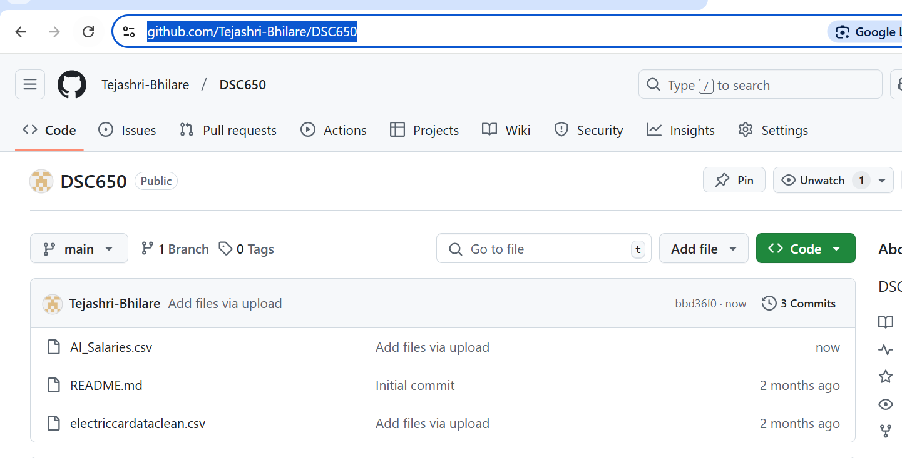

Github URL for RAW csv file.

https://raw.githubusercontent.com/Tejashri-Bhilare/DSC650/refs/heads/main/AI_Salaries.csv

- Change into the nifi directory with
cd dsc650-infra/bellevue-bigdata/nifi

- Start NiFi using the command:
/bin/bash nifi-*/bin/nifi.sh start



NiFi Flow:
- GetHTTP Processor
  - URL: https://raw.githubusercontent.com/Tejashri-Bhilare/DSC650/refs/heads/main/AI_Salaries.csv
  - Fetch data and pass to the next processor.
- PutHDFS Processor
  - Store file in HDFS at /data/AI_Salaries.csv.

- Access the NiFi User Interface

Have used the provided NiFi template to pull my chosen dataset into HDFS.

Replaced HTTP URL with my own profile’s xml file

/home/ubuntu/dsc650-infra/bellevue-bigdata/nifi/hadoopconf/core-site.xml

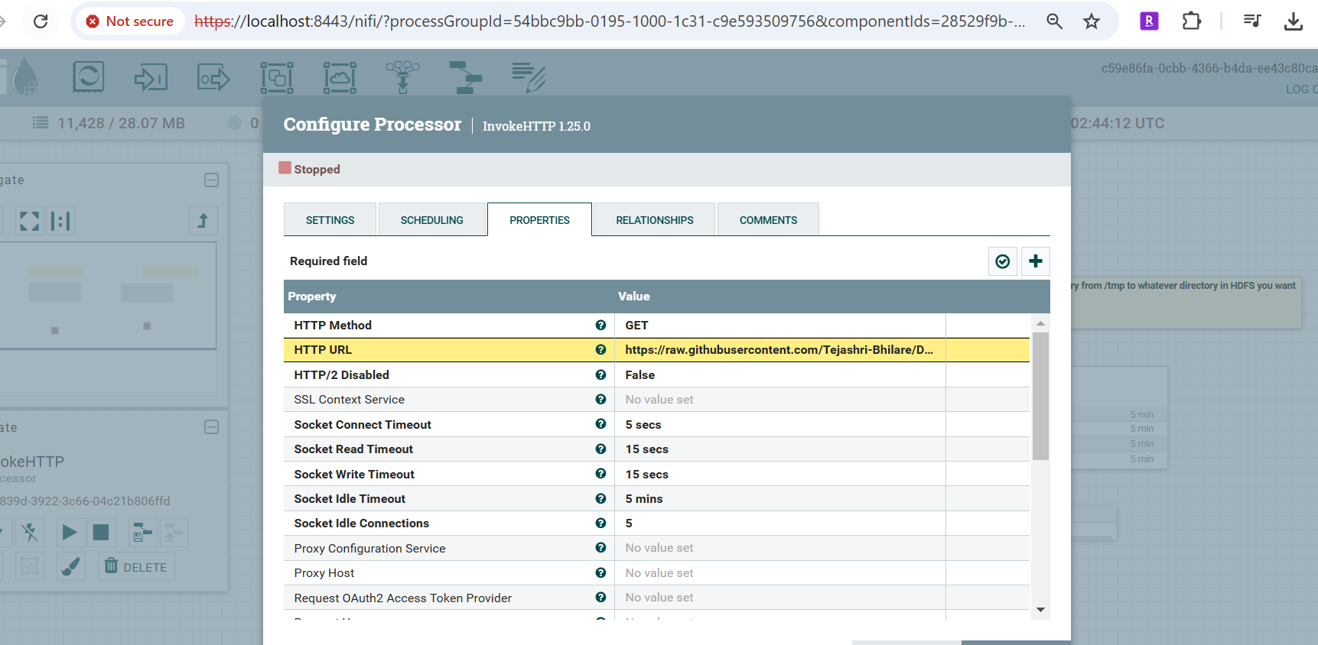

Executed Nifi process to load data

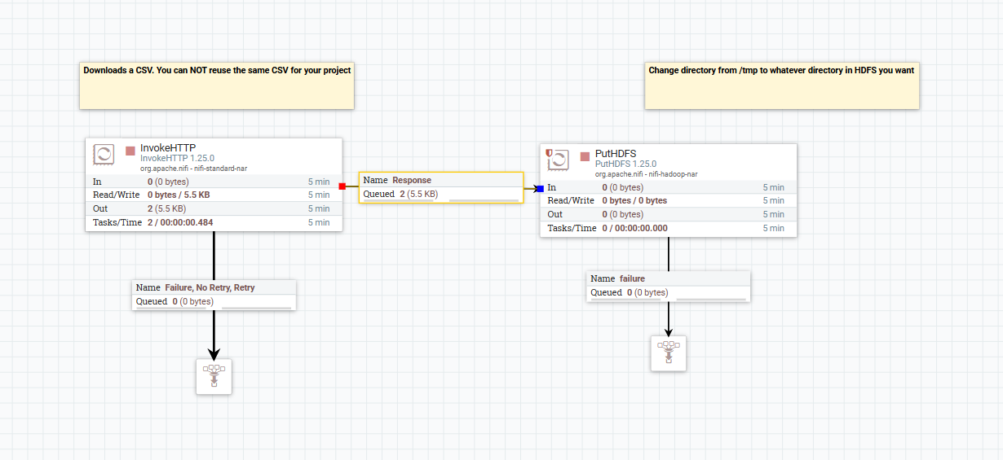

Data from the logs.

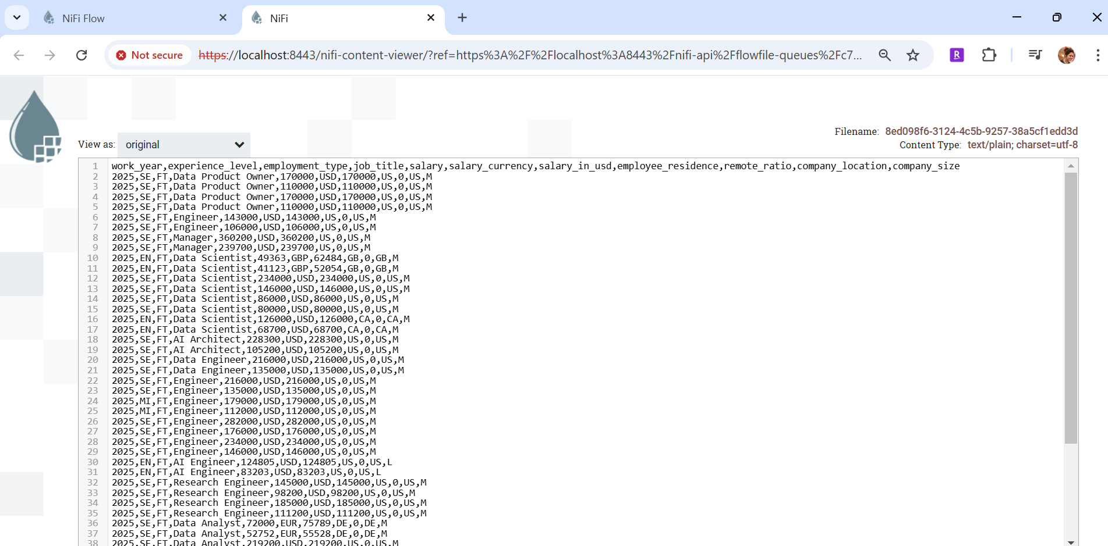

Once job completed successfully , stopped NIfi process.

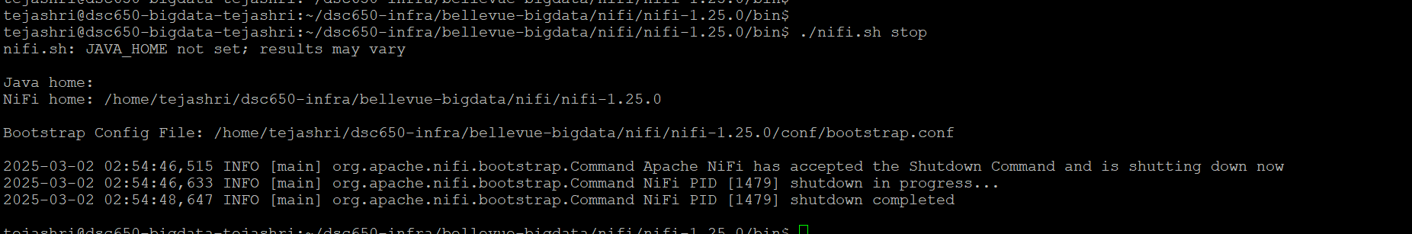

Verify that file loaded successfully into hdfs

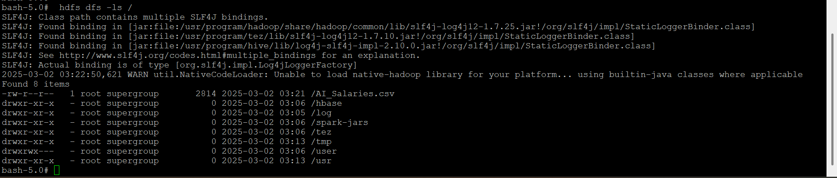

Create Hive Table

CREATE TABLE ai_salaries(
id INT,
job_title STRING,
salary INT,
experience_level STRING,
employment_type STRING,
work_setting STRING,
company_location STRING,
company_size STRING
)
ROW FORMAT DELIMITED
FIELDS TERMINATED BY ','
STORED AS TEXTFILE
tblproperties("skip.header.line.count"="1");

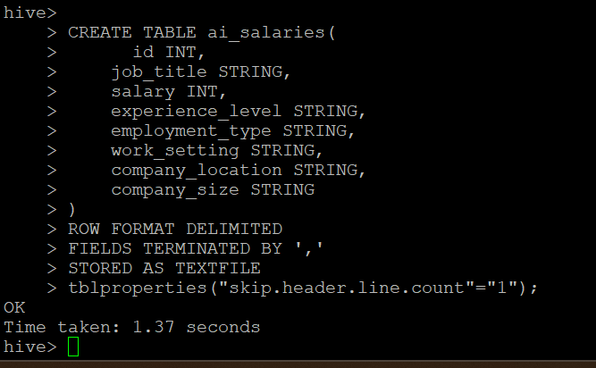

Loading data into the hive table.
LOAD DATA INPATH '/AI_Salaries.csv' INTO TABLE ai_salaries;
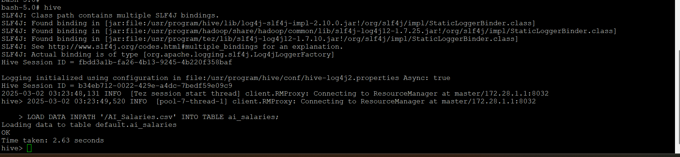

Verify that data has been loaded successfully.

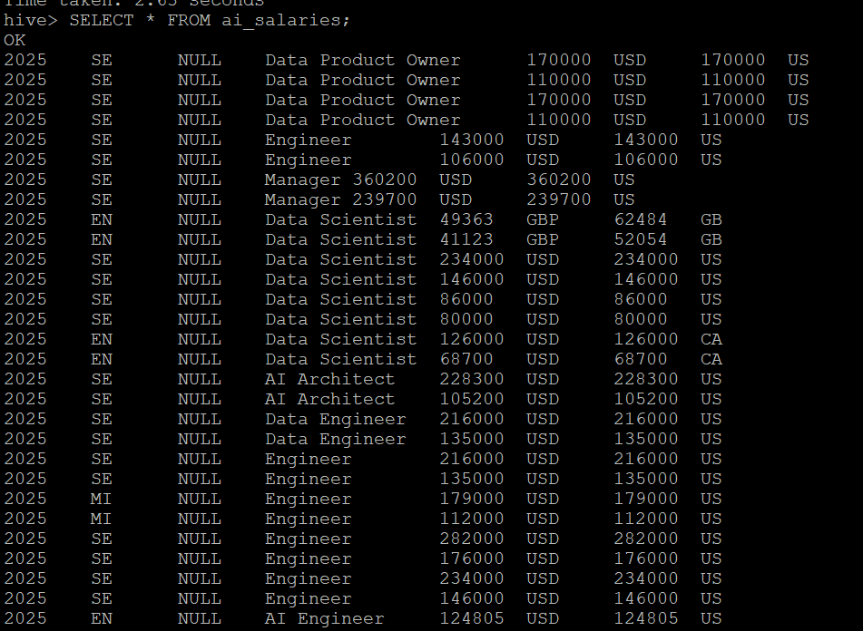

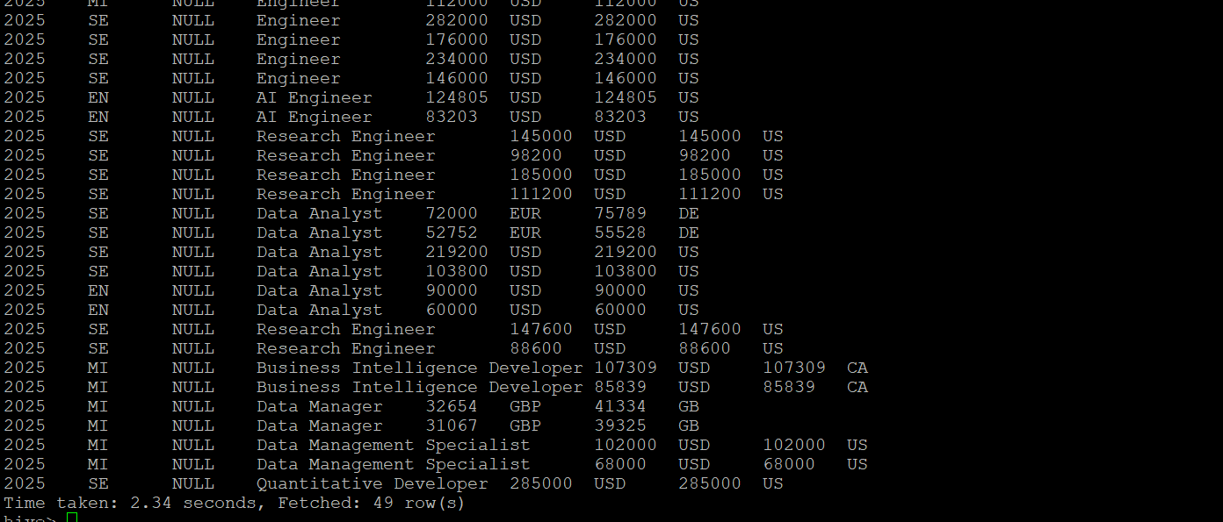

Execute Queries on the loaded ai_salaries table

1) Retrieve the Top 10 Highest-Paid AI Jobs

SELECT job_title, salary, company_location, experience_level
FROM ai_salaries
ORDER BY salary DESC
LIMIT 10;

Above query finds the highest-paying AI jobs along with their locations and experience levels.
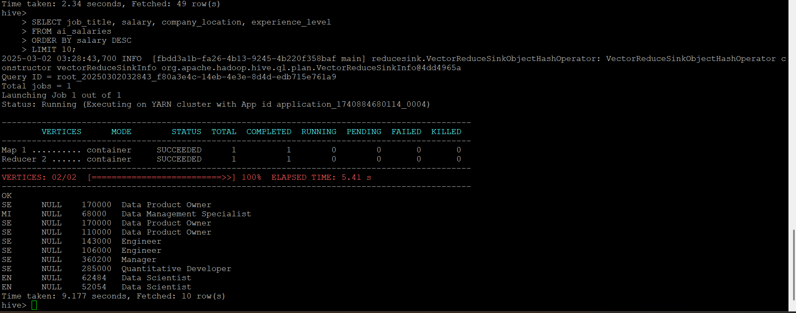

2. Count the Number of AI Jobs by Experience Level
SELECT experience_level, COUNT(*) AS job_count
FROM ai_salaries
GROUP BY experience_level
ORDER BY job_count DESC;
Above query shows how many AI jobs exist for each experience level.

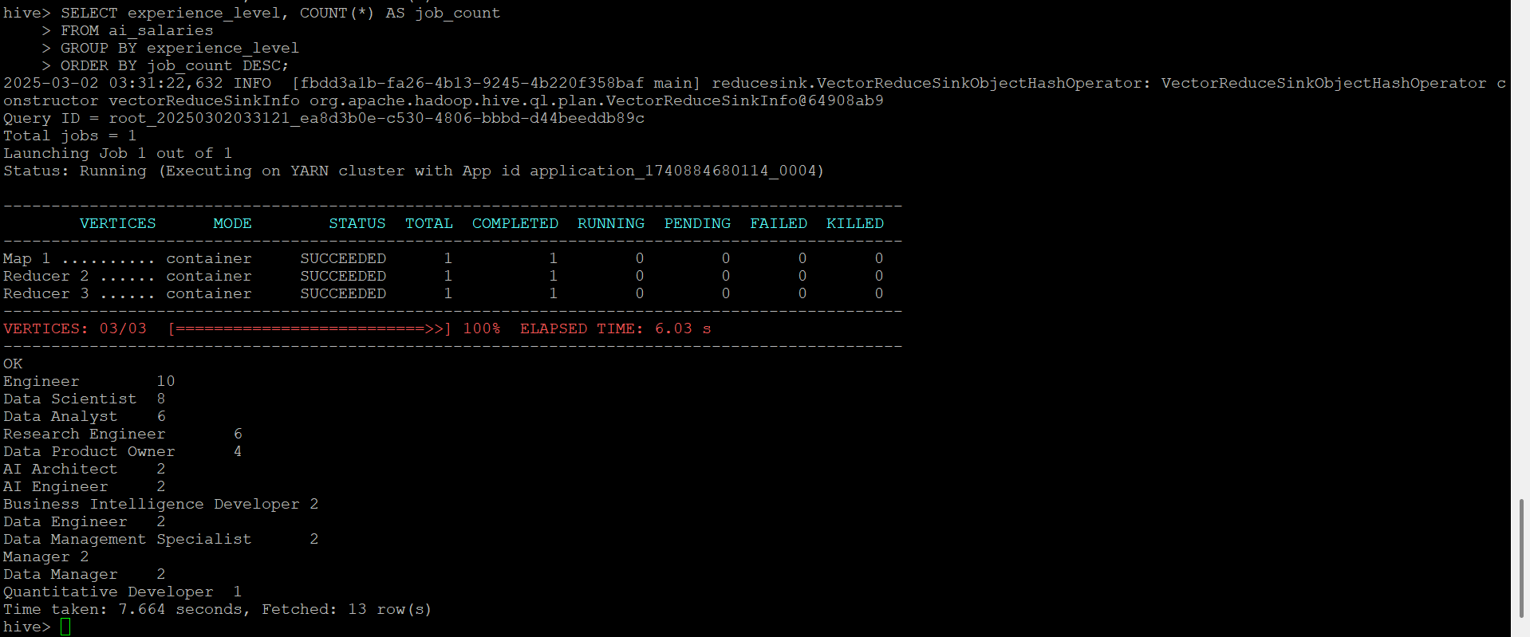

3. Find the Average Salary for Remote, Hybrid, and On-Site Jobs

SELECT work_setting, ROUND(AVG(salary), 2) AS avg_salary
FROM ai_salaries
GROUP BY work_setting;

Above query compares the average salary for different work settings (remote, hybrid, on-site).

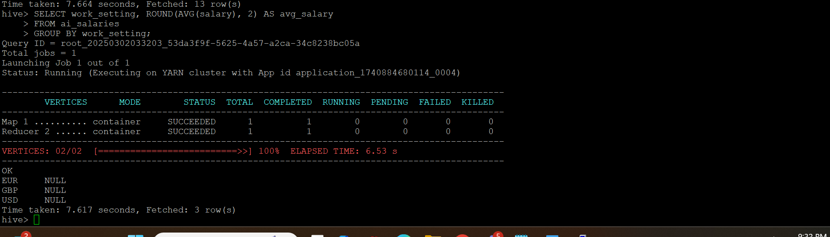

4. Get the Number of AI Jobs by Company Size
SELECT company_size, COUNT(*) AS job_count
FROM ai_salaries
GROUP BY company_size
ORDER BY job_count DESC;

Above query analyzes which company sizes offer the most AI jobs.

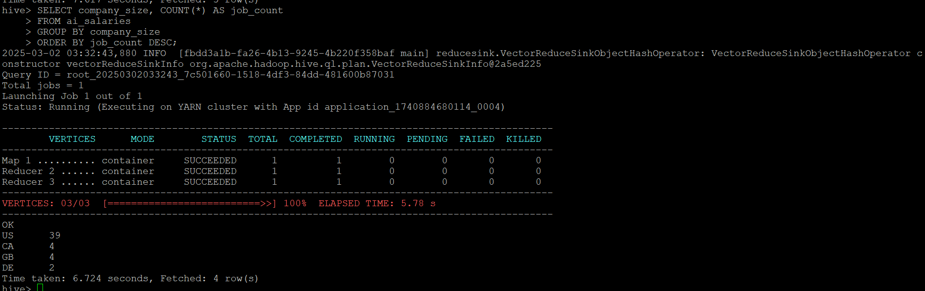

5. Find the Highest-Paid Job for Each Experience Level
SELECT experience_level, job_title, salary
FROM ai_salaries a
WHERE salary = (
SELECT MAX(salary)
FROM ai_salaries
WHERE experience_level = a.experience_level
);

Above query finds the highest-paying job for each experience level.
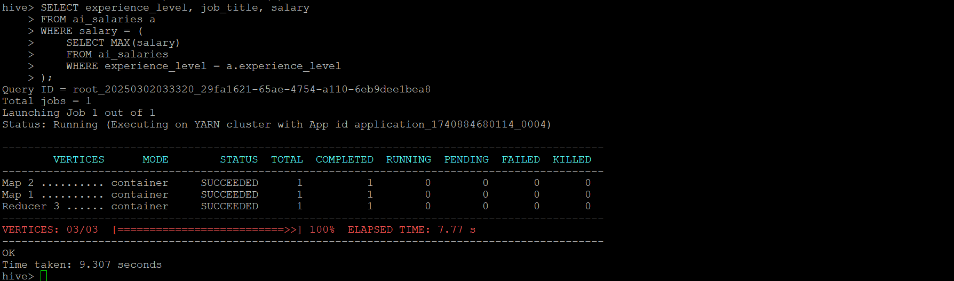

Processing Data in Spark

Enter into pyspark shell.

Pyspark
spark.sql("SHOW TABLES").show()

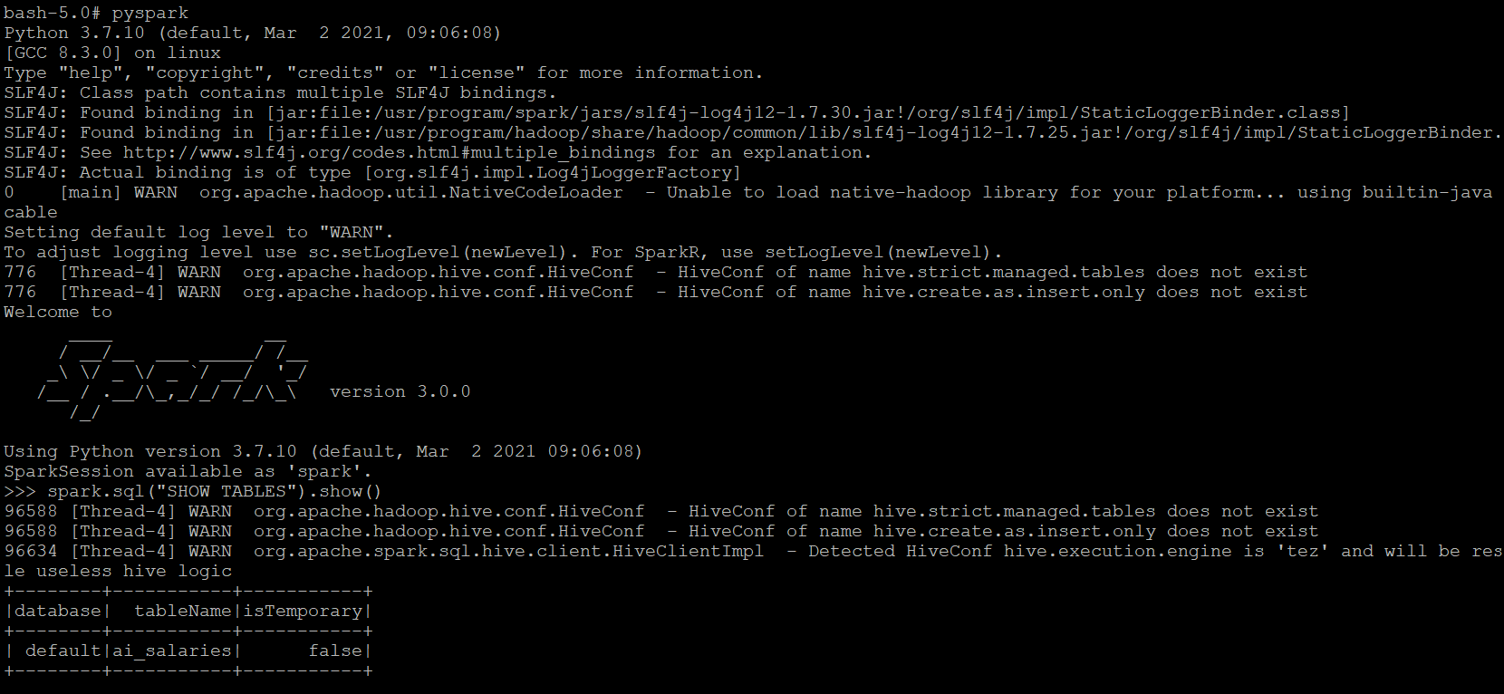

1. Retrieve the Top 10 Highest-Paid AI Jobs

spark.sql("""
SELECT job_title, salary, company_location, experience_level
FROM ai_salaries
ORDER BY salary DESC
LIMIT 10
""").show()

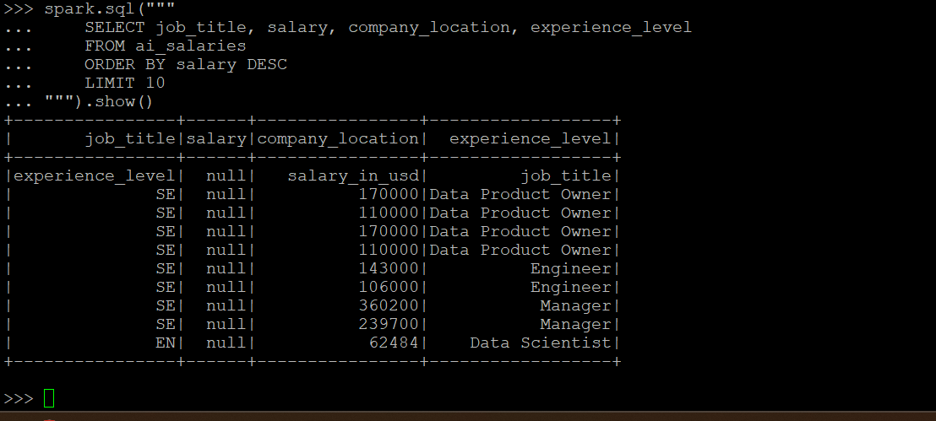

2. Count the Number of AI Jobs by Experience Level

spark.sql("""
SELECT experience_level, COUNT(*) AS job_count
FROM ai_salaries
GROUP BY experience_level
ORDER BY job_count DESC
""").show()
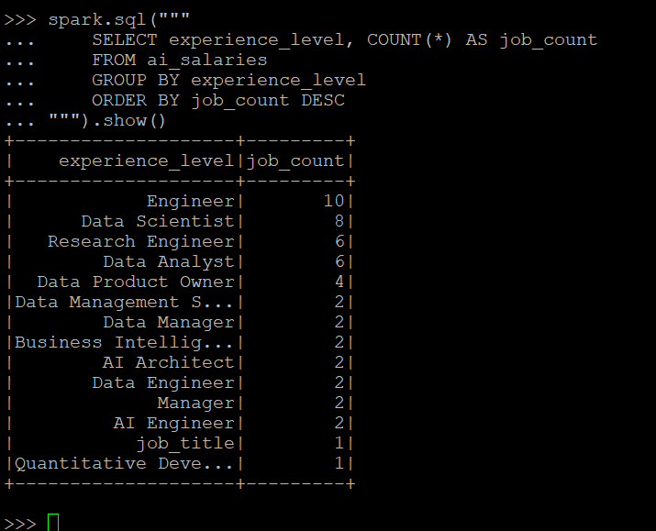

3. Find the Average Salary for Jobs

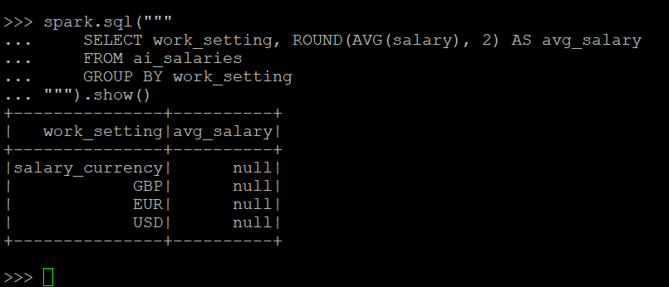

4. Get the Number of AI Jobs by Company Size
spark.sql("""
SELECT company_size, COUNT(*) AS job_count
FROM ai_salaries
GROUP BY company_size
ORDER BY job_count DESC
""").show()

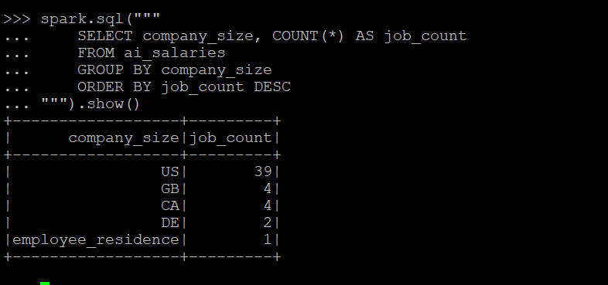

5. Issues Encountered & Resolutions

1) NiFi connection issues while fetching GitHub data -> Used GetHTTP processor with correct URL and verified network access.

2) Hive schema mismatch due to header row -> Used ROW FORMAT DELIMITED FIELDS TERMINATED BY ',' and ensured proper column mapping
3) Large dataset processing in Spark causing memory issues -> Used .show(10, false) to limit output and avoid excessive memory usage

4) My spark shell , crashed down almost 3-4 times while executing SQL queries , so need to modify queries in order to fetch data.

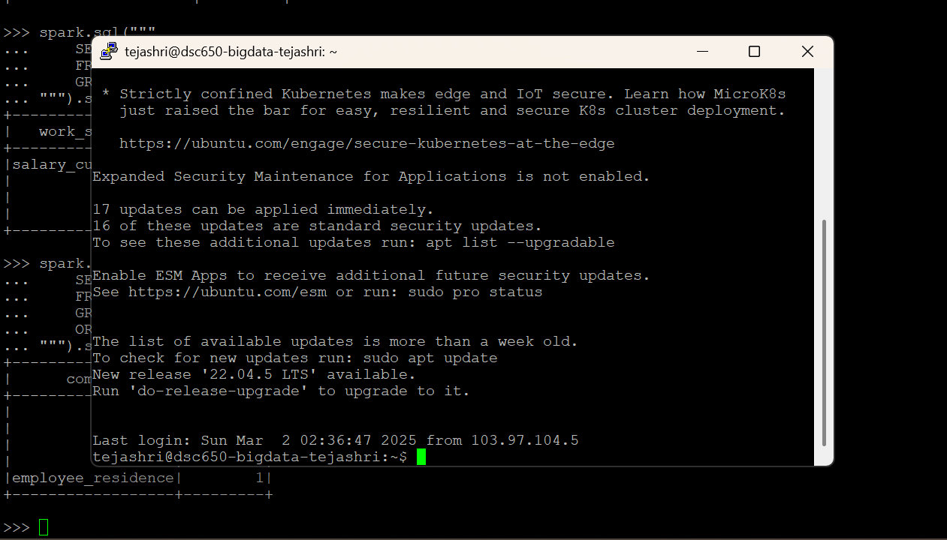

Conclusion
- Successfully ingested, stored, and processed AI Salaries data using a distributed pipeline.
- Spark SQL enabled fast querying and insights into salary trends.
- The project demonstrated the integration of NiFi, HDFS, Hive, HBase, and Spark in a real-world scenario.

